**Business Problem**

In recent years, City Hotel and Resort Hotel have seen high cancellation rates. Each hotel is now dealing with the number of issues as result, including fewer revenues and less than ideal hotel room use.

Consequently, lowering cancellation rates is both hotels’ primary goal in order to increase their deficiency in generating revenue, and for us to offer through business advice to address this problem.

The analysis of hotel booking cancellations as well as other factors that have no bearing on their business and yearly revenue generation are the main topics of this project.



**Assumptions**

1. No unusual occurrences between 2015 and 2017 will have a substantial impact on the data used.
2. The information is still current and can be used to analyse a hotel’s possible plans in an efficient manner.
3. There are no unanticipated negatives to the hotel employing any advised techniques.
4. The hotels are not currently using any of the suggested solutions.
5. The biggest factor affecting the effectiveness of earning income is booking cancellation.
6. Cancellations result in vacant rooms for the booked length of time.
7. Clients make hotel reservations the same yar they make cancellations.



**Research Questions**

1. What are the variables that affect hotel reservation cancellations?
2. How can we make hotel reservation cancellations better?
3. How will hotels be assisted in making pricing and promotional decisions?

**Hypothesis**

1. More cancellations occur when prices are higher.
2. When there is a longer waiting list, customers tend to cancel more frequently.
3. The majority of clients are coming from offline travel agents to make their reservations.



**Analysis & findings**

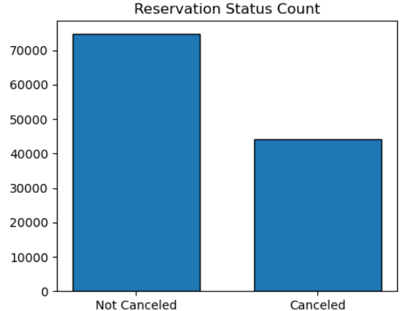

The accompanying bar graph shows the percentage of reservations that are calculated and those that are not calculated. It is obvious that there are still a significant number of reservations that have not been cancelled. There are still 37% of clients who cancelled their reservations, which has a significant impact on the hotel’s earnings.

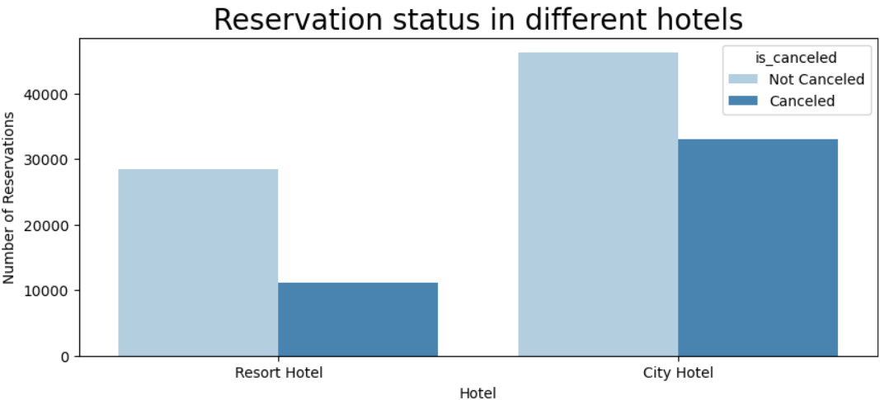

In comparison to Resort hotels, City hotels have more bookings. Its possible that resort hotels are more expensive than those in cities.

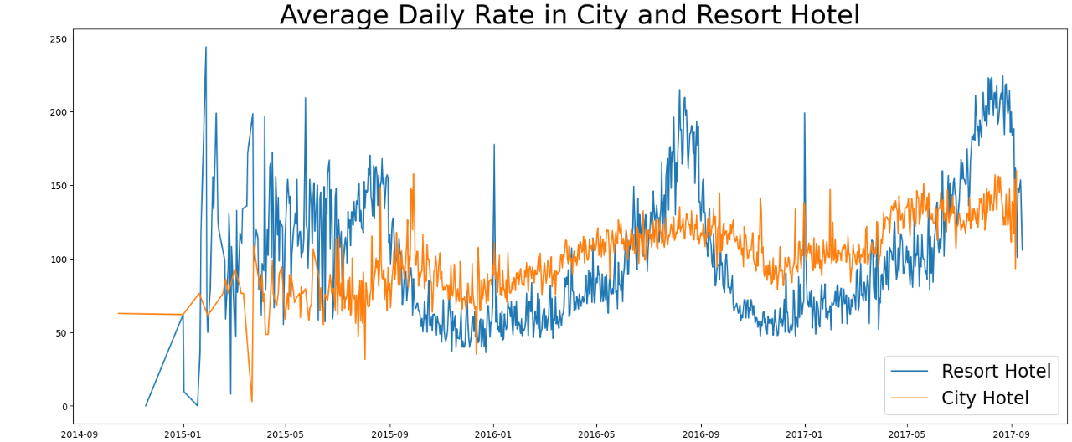

The above line graph shows that on certain days, the average daily rate for a city hotel is less than that of resort hotel and on other days, it is even less.

It goes without saying that weekends and holidays may see rise in resort hotel rates.

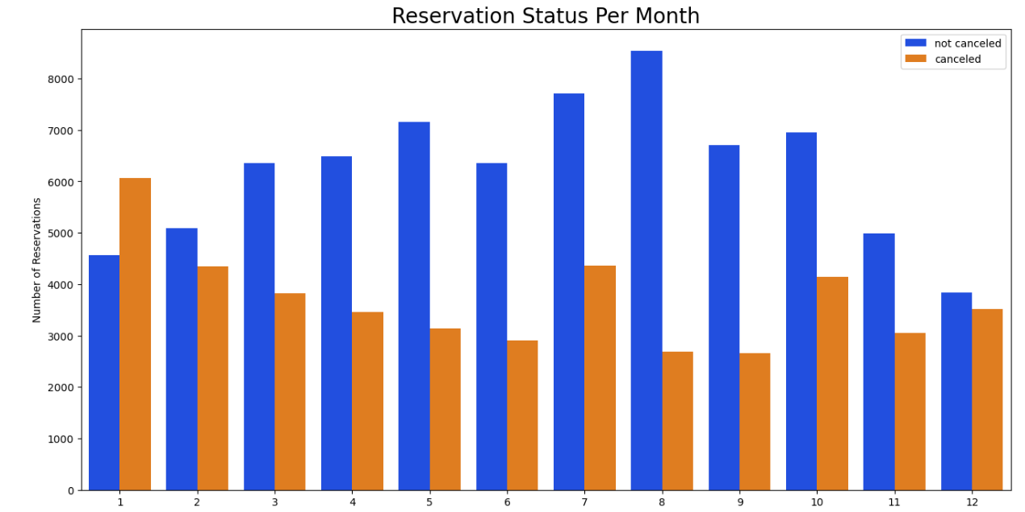

We have developed a grouped bar graph to analyse the months with the highest and lowest reservation levels according to their reservation status.

As we can see here the number of confirmed reservations are higher for the month of August followed by July. Whereas January is the month with the most cancelled reservations followed by February.

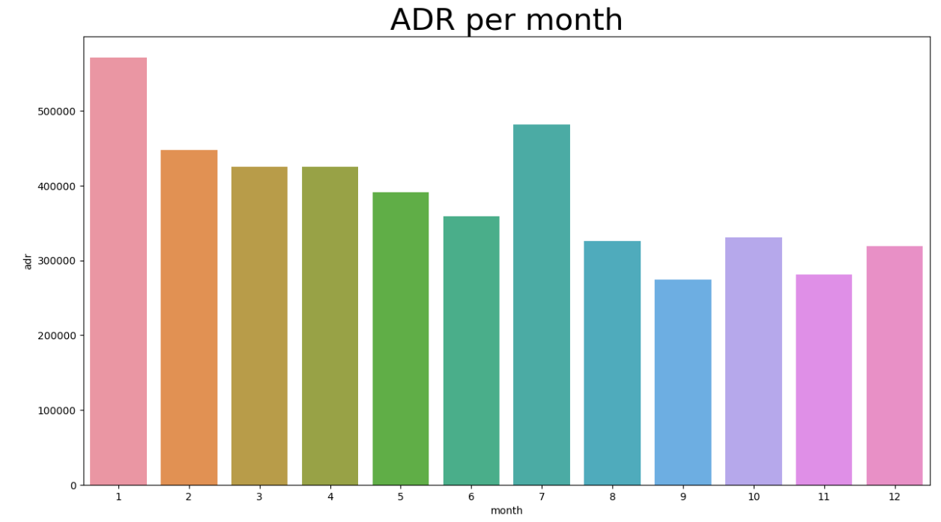

The bar graph demonstrates that cancellations are most common when prices are greatest and are least common when they are lowest. Therefore, the cost of the accommodation is solely responsible for the cancellation.

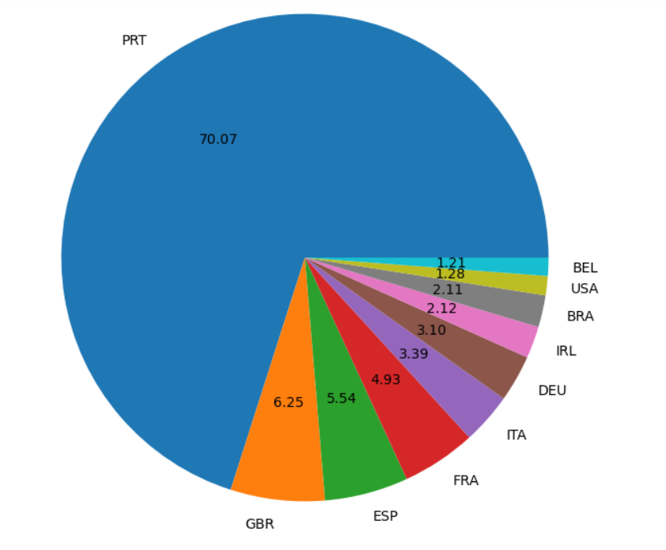

The top country is Portugal with the highest number of cancellations where as lowest number of cancellations happen in Belgium followed by USA.

**Suggestions**

1 Cancellation rates rise as the price does. In order to prevent cancellations of reservations, hotels could work on their pricing strategies and try to lower the rates of specific hotels based on locations. They can also provide some discounts to the customers.

2. As the ratio of the cancellation and not cancellation of the resort hotel is higher in the resort hotel than City hotels. So the hotels should provide a reasonable discount on the room prices on weekends or on holidays.

3.In the month of January, hotels can start campaigns or marketing with a reasonable amount to increase their revenue as the cancellation is highest in this month.

4.They can also increase the quality of their hotels and their services mainly in Portugal to reduce in cancellation rates.

